Alberta Oil Sands- Awareness Poster
Name: ____________________________
Due Date: _____________________________
The Alberta Oil Sands has raised much discussion between environmentalist and the oil industry. The oil Sands are mixed with bitumen which is a form of crude oil. This paste is difficult to remove from the sand making it very expensive to produce this conventional oil.
On a large paper create an awareness POSTER to show the positives and negatives of the Alberta Oil Sands.
Use the checklist below to make sure you include all information required.
Use pages 165-168 in your Time and Place Workbook and the internet to help you

Alberta Oil Sands /6
Where are the Oil Sands Located? /2 Who Exploits Alberta’s Oil Sands /2
Who Benefits from Alberta’s Oil Sands /2
Advantages and Disadvantage /4
List 2 Advantages of the Alberta Oil Sands /2 List 2 Disadvantages of the Alberta Oil Sands /2
Solutions /2
Two Alternative Sources of Energy /2
Overall Presentation /3
Title, Pictures and Colour /2 Spelling and Neatness /1
/15
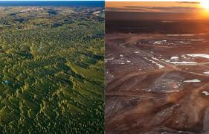
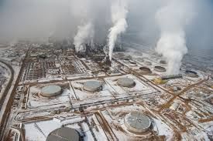

Alberta Oil Sands /6
Where are the Oil Sands Located? /2 Who Exploits Alberta’s Oil Sands /2
Who Benefits from Alberta’s Oil Sands /2
Advantages and Disadvantage /6
List 2 Advantages of the Alberta Oil Sands /2 List 2 Disadvantages of the Alberta Oil Sands /2
What are the environmental impacts of the Oil Sands /2
Solutions /4
Two Alternative Sources of Energy /2 Where are these Alternative sources located? /2
Presentation /4
Title and Colour /1 Overall Presentation (visual, spelling, etc.) /2
Includes Pictures /1 /20

Alberta Oil Sands /6
Where are the Oil Sands Located? /2 Who Exploits Alberta’s Oil Sands /2
Who Benefits from Alberta’s Oil Sands /2
Advantages and Disadvantage /6
List 2 Advantages of the Alberta Oil Sands /2 List 2 Disadvantages of the Alberta Oil Sands /2
What are the environmental impacts of the Oil Sands /2
Solutions /4
Two Alternative Sources of Energy /2 Where are these Alternative sources located? /2
Presentation /4
Title and Colour /1 Overall Presentation (visual, spelling, etc.) /2
Includes Pictures /1 /20

