European Expansion in the World: Essay Writing Assignment
Document File

Economic Consequence(s)
Document #1(Gold Shipments to Spain Between 1503 and 1660)

Document #2 (A Mercantilist Policy)
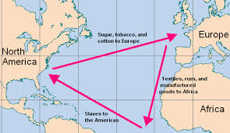
“He takes great delight in watching other people’s gold flow into the Kingdom of France; but so too does he work jealously and tirelessly to prevent any [gold] from leaving.”
Document #3 (Triangular Trade)

Document #4 (King Alfonso of the Congo Writes to the King of Portugal)
“They capture them and take them away to be sold. This corruption and licence is so great, Sire, that our country has been completely depopulated. So we beg your Majesty to come to our aid by ordering that no more merchants or merchandise be sent here. It is our desire that our kingdom be free of trade in slaves and of the facilities designed for that purpose.”
Document #5- Slave Trade
African slaves were imported into Spain’s New World possessions in the early 16th century, as well as into the Portuguese possession of Brazil and, somewhat later, into the British colonies of North America. However, it was not until the development of sugar, cotton, and tobacco plantations in the Americas that the Atlantic slave tradereached huge proportions, exceeding any such earlier trade. The British became the major traders in slaves, although the French, the Dutch, and others also took part.
http://school.eb.com/levels/middle/article/272745#195891.toc
Socio-Cultural Consequence(s)
Document #1 (The Enslavement of the Native Peoples)
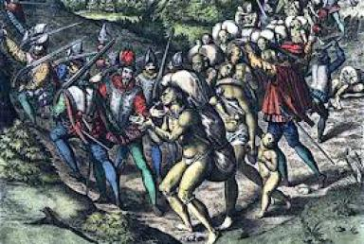
Document #2 (The Massacre of the Native peoples, according to Las Casas)
“To these quiet Lambs, endued with such blessed qualities, came the Spaniards like most cruel Tygres, Wolves, and Lions, enrag’d with sharp and ferocious hunger […] they have so cruelly and inhumanely butchered, that of three millions of people which Hispaniola (Haiti) it self did contain, there are left remaining alive scarce three hundred persons.”
Document #3 (The Extinction of Mexico’s Native Peoples)

Document #4 (Missionaries of Death)
“The Christian missionaries are casting spells on us and making us die. They came into a village where everyone was doing just fine; as soon as they arrived, everyone died. They went to visit some cabins in other settlements, and it is only the places where they never set foot that have been spared of death and illness.”
- Marie de l’Incarnation, 1640

Document #5 (Clash of Cultures)
“ They all go as naked as when their mothers bore them, even the women… Weapons they have none, nor are acquainted with them, for I showed them swords, which they grasped by the blades and cut themselves through ignorance… I am of the opinion that they would very readily become Chritians, as they appear to have no religion.”
Christopher Columbus’s Ship’s Logbook, 1492
Document #6 (Different Views on Life)
 | European View | Indigenous View
The Human Being’s Place in Nature | Humans must dominate nature. | Humans must live in harmony with nature.
The Trading of Goods | Trading is a commercial activity. Money is exchanged. | Trade has economic, religious, political, military and social significance. Goods are exchanged using barter.
Laws | Laws are written down. | Laws are orally transmitted.
Political Power | European states are organized into large states. The king command, his subjects obey. | Organized into small tribes. The chief of a tribe has the power to persuade, but not command.
Production | Surpluses are produced so they can be sold for a profit. | People only produce what they need.
Land | Land belongs to the country that finds it. | Land belongs to no one.

Document #7 (African Slave Trade)
Country | Number of Slaves (taken from Africa)
Portugal | 4 650 000
Spain | 1 600 000
France | 1 250 000
England | 300 000
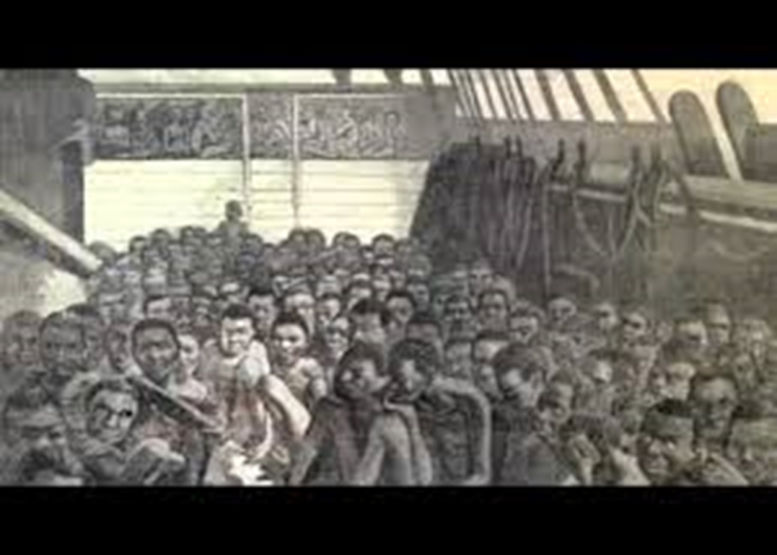
Document #8 (The Middle Passage)

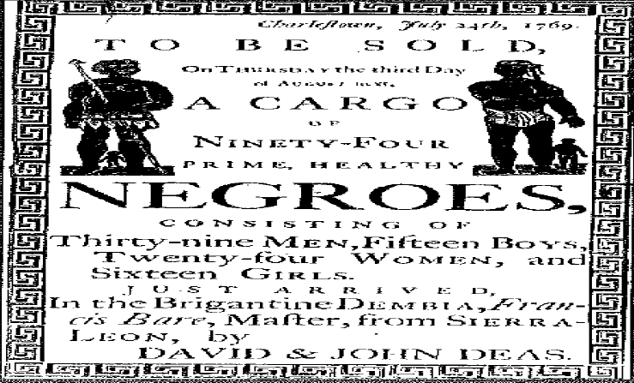

Document #9 (Sold like Cattle)

Newspaper advertisement from Charleston in 1769
The History of Slavery: In the South Carolina
LowCountry, Douglas W. Bostick 2014

