Symmes HISTORY
2015-2016
Teacher: Mrs. J. Ray Email: jray@wqsb.qc.ca

Room 205 Website: jraysymmes.weebly.com

History
Students will learn how to properly research for an historical project in order to prevent plagiarism. Student will understand the significance of historical events in the world we live in today.

UNITS THIS YEAR

Term 1: Sedentarization, Mesopotamia, Ancient Egypt and Persia, Ancient Greece
Term 2: Ancient Rome, Medieval Society, The Renaissance and Humanism, European Expansion in the World
Term 3: Fundamental Rights and Revolutions, Industrialization: an Economic and Social Revolution, Imperialism and Colonization, Recognizing Rights and Freedoms

Homework:
- Exercises not completed in class should be completed at home
- If students have no assigned homework they can revise their notes
- *Homework is posted on the homework board at the front of the classroom.
- Students must use agenda to copy homework down.

Note: Any infraction of the class rules will be dealt with immediately in the following manner:
- Verbal warning
- Students sent to reflection room (in the event behaviour prevents others from learning)
- Noon hour detention (for late arrival or to complete incomplete homework)
- Wednesday afternoon detention (when major assignment is not handed in)
- Late assignments will receive a 2% deduction per day and will not be accepted 14 days past the deadline.

Evaluation:
Term 1: 20% Course work (Projects, tests and quizzes)
Term 2: 20% Course work (Projects, tests and quizzes)
Term 3: 30% Course work (Projects, tests and quizzes)
History Final Exam: 30% The final exam will include content from the second half of the year

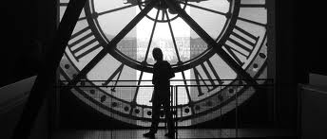
When students are absent they are responsible to get the work completed and to get handouts that they missed.

Have a great year,
Mrs. Ray

